|  |  |
| --- | --- |
| RFID Guard |  |





**Introduction to Networks Project- Spring 2018/2019**

**TEAM MEMBERS:**   
 Name:  **ID:**

**AHmed SALEM 17107813**

**AHMED SAMY 17107763**

**MARWAN AYMAN 17107676**

**AL-FAROUK AHMED 17107672**

**SupervisorS:**

**Dr. MOHAMED MOSTAFA EL-TAWEEL**

Assistant Professor

Arab Academy for Science, Technology, and Maritime Transport

**Eng. Abdelrahman Elewah**

Teaching Assistant

Arab Academy for Science, Technology, and Maritime Transport

|  |  |
| --- | --- |
| RFID Guard |  |

Table of Contents

**Abstract3**

**Problem Definition 3**

**The Project Aim3**

**Model4**

**Functional and non-Functional 4,5**

**Hardware Requirements……………………………………………………………………………….5,6**

**Intended users and key usability goals6**

**Challenges During the project7**

**References 7**

|  |  |
| --- | --- |
| RFID Guard |  |

**Abstract:**

• An IOT solution

• An RFID lock system connected to a database of an online website

• It monitors the use of utilities to prevent their stealing

• It prevents illegal access to expensive items

**Problem Definition:**

As we are having a major leap in technology, we are facing lack of security and safety for expensive equipment. So, we introduce to you our “RFID GUARD”. A system that helps the client feel safe 100% any time because he’s sure that no one will have access to the equipment except him. This RFID ACCESS SYSTEM is built to allow access and open only in the case of showing the right ID and passing it in front of the reader, otherwise the system will reject anybody who illegally tries to open the locked box.

**The Project Aim:**

System locks the client’s equipment inside it with a solenoid door lock which opens only if the RFID reader recognizes the right ID passed in front of it.

**Project Description:**

The Project is to implement a RFID reader that scans the ID of the accessor and checks in an online secure database if this accessor is authorized to gain access or not for the equipment locked inside the box, as well as, it saves his data and access time to track the usage of the equipment.

|  |  |
| --- | --- |
| RFID Guard |  |

**Model:**

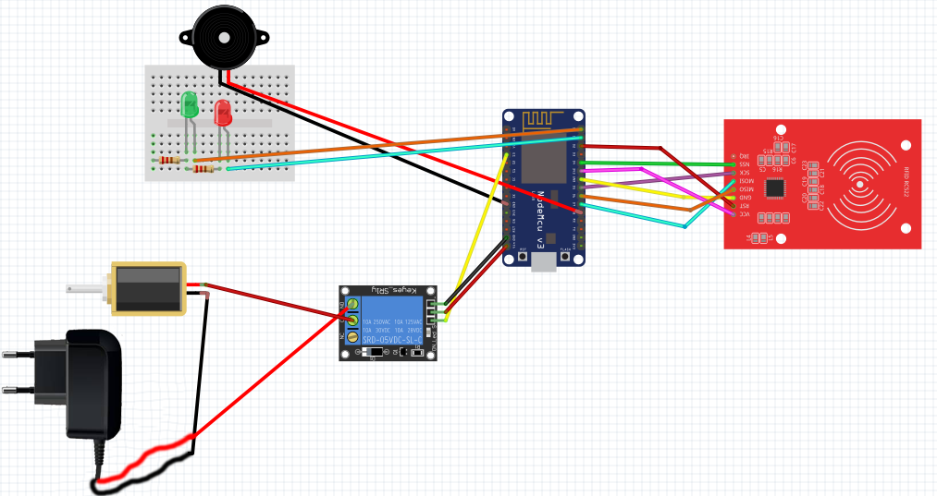

**Functional:**

The main functionalities of the system are:

1. **Solenoid Door Lock:** A door with solenoid lock is locked and not opened in case of power failure or wire disconnection, ensuring excellent safety.
2. **Relay DC 12V Module:** used to control the current flow to the lock.
3. **NodeMCU**: is an open source IoT platform. It includes firmware which runs on the ESP8266 Wi-Fi and HTTP protocols.
4. **DC Adaptor 12V:** used to supply the current to the lock.

**Non-Functional:**

The main non-functionalities of the system are:

* **Security:** System will save all entries in a secure database to monitor who accessed the equipment.
* **performance:** The system shall accommodate a high number of users without any fault.
* **Usability:** The system will be very easy to operate and use as it offers an online panel which is very user friendly.

|  |  |
| --- | --- |
| RFID Guard |  |

**Hardware Requirements**

|  |  |  |  |  |  |
| --- | --- | --- | --- | --- | --- |
| **Item** | **Type (Hardware/ Software/ Other)** | **Specification** | **Possible Provider/ Merchant** | **Quantity** | **Price in EGP** |
| * NodeMCU | Hardware | * ESP8266 WIFI Development Board | [RAM Electronics](https://ram-e-shop.com/product/kit-node-mcu/) | 1 | 150 |
| * Channel Relay Module | Hardware | DC 12V | [RAM Electronics](https://ram-e-shop.com/product/kit-4relay/) | 1 | 65 |
| RFID Reader RC522 + RFID tags | Hardware | Mifare MFRC522 RFID Reader/Writer | [RAM Electronics](https://ram-e-shop.com/product/kit-rfid-rc522/) | 1 | 125 |
| * Red LED * Green LED * Buzzer | Hardware |  | [RAM Electronics](https://ram-e-shop.com/product/3mm-led-rr/)[RAM Electronics](https://ram-e-shop.com/product/3mm-led-gg/)[RAM Electronics](https://ram-e-shop.com/product/buzzar3v/) | 1 | 0.25 0.25  5 |
| * Solenoid Door Lock | Hardware | * DC 12V | [RAM Electronics](https://ram-e-shop.com/product/solenoid-lock-12vdc/) | 1 | 125 |
| * Connecting * Jumpers | Hardware | M-M  M-F | [RAM Electronics](https://ram-e-shop.com/product/ph-male-female-30cm/) | 10  8 | 18 |
| * Mini Breadboard | Hardware |  | [RAM Electronics](https://ram-e-shop.com/product/bb601-white/) | 1 | 10 |
| * Adaptor | Hardware | AC/DC 12V – 3A | [RAM Electronics](https://ram-e-shop.com/product/adaptor-fixed-12v-3a/) |  | 70 |
| **Grand Total** | | | |  | 570 |

|  |  |
| --- | --- |
| RFID Guard |  |

**Intended users and key usability goals:**

**Intended users:** Students, Employees and any intended user who needs to protect any type of equipment from illegal access or who wants to track any equipment’s usage.

**Benefits:**

1. Saves a log with people who have accessed the equipment.
2. It allows people with authorized access only and prevents those who are without.

**Challenges during the project’s development:**

1. Using a smaller bread board
2. Coding the nodemcu
3. Connecting the door lock
4. Linking with an online database
5. Handling the requests through an online server

**References:**

<https://www.instructables.com/>

<https://circuits4you.com/>

<http://fritzing.org/home/>